**EXERCISE NO: 11**

**DATE: 22/11/2020**

**AIM:**

To get the gcd for the numbers.

**PROGRAM:**

def gcd(a,b):

gcd = 1

if a%b == 0:

return b

for k in range(int(b / 2), 0, -1):

if a%k == 0 and b%k == 0:

gcd = k

break

return gcd

a = int(input("Enter first number:"))

b = int(input("Enter second number:"))

GCD = gcd(a,b)

print("GCD is: ")

print(GCD)

**OUTPUT:**

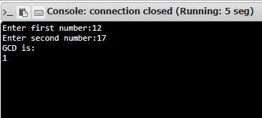

**LINK:** [**http://103.53.53.18/mod/vpl/forms/edit.php?id=326&userid=1712**](http://103.53.53.18/mod/vpl/forms/edit.php?id=326&userid=1712)

**RESULT:**

Thus GCD of the numbers is displayed.